1. **PROJECT DETAILS**

Complete the following table with respective project details (copy-paste as appropriate from last report):

|  |  |
| --- | --- |
| **Project Number** | P3589-MYP |
| **Project Title** | CBM-BCH ENT Project |
| **City/ Country/ Region** | Lusaka/Zambia/Southern Africa |
| **Project Duration** | 01/01/2018 -31/12/2022 |
| **Total approved budget amount (in EUR)** | 845,291.66 |
| **Total budget expenditure amount (in EUR)** | 314,824.27 |
| **Name of Contractual Partner** | Beit Cure Hospital |
| **Other Implementing Partners** | None |
| **Report contact person at Partner / Project** | Steven Chishimba |
| **Date of report submission** | 7th of January, 2022 |
| **Report contact person at CBM** | Slinganiso Homela (Program Officer) |

1. **NARRATIVE REPORT**

## **To what extent were the Objectives achieved?**

**Overall Objective: Strengthened Ear Nose and Throat (ENT) Services in Zambia that contribute to an improved quality of life of persons with hearing impairments and their families.**

***Indicator 1: Number of accessible and affordable ENT services provided within Lusaka province.***

***Target: 18,448.***

During the period under review, the project successfully achieved a success of 98% on its set target equivalent to 18, 041 beneficiaries reached. The period was characterized by the ongoing pandemic which threatened to de-stabilize Hospital operations but with prudent strategic leadership and strategic project implementation the project managed to mitigate the challenges and ensure the continuation of implementation project activities.

***Indicator 2: Strengthening ENT, Audiology and Speech Therapy services in the Zambian Health System.***

During the period under review, the project worked in close collaboration with the Ministry of Health (MoH) as evidenced by the project’s participation during the launch of the first ever World Report on Hearing as part of the World Hearing Day Celebrations. In addition to this the project intends to continue its efforts in supporting the establishment of the National ENT Committee which will further strengthen the National Health System.

***Indicator 3: Improved and effective operational management of the ENT clinic.***

Overall, through the support of the project, the Hospital successfully managed to have a robust operational and programmatic system that contributed to its 98% achievement rate. The project established a Mobile and School Screening Outreach programme as well as a systematic M&E system that continuously provided feedback to the project team to ensure effective project implementation.

**Specific Objective: Provide comprehensive, accessible and affordable ENT clinical and surgical services as well as audiological services for people with hearing impairment.**

***S.O Indicator 1: Number of effective consultations that lead to appropriate treatment of patients.***

***Target: 17,968***

The project successfully achieved 98% (17,567 consultations) on the set target during the period under review.

***S.O Indicator 2: Number of quality surgeries with good medical outcomes.***

***Target: 480***

During the period under review, the project successfully achieved 99% on this specific objective, representing 479 surgeries, and this was made possible due to an increase in the Outreach activities specifically with the school screenings. After successfully upscaling the school screening efforts, it was observed that the project had more referrals of Children from School Screenings which in turn increased the number of surgeries.

# **To what extent were the planned Results achieved or not during the reporting period?**

**Result Area 1: ENT (diagnostic and surgery) and rehabilitative services (audiology and auditory-verbal therapy) provided to a larger number of patients.**

During the period under review, the project successfully achieved a 98% completion rate on all the planned activities under the result area. The project successfully reached out to 18,041 beneficiaries out of the set target of 18,448 patients. The breakdown was as follows: Consultations (133%), Surgeries (99%), School Screenings (111%), Audiology Consultations (104%) and Speech Therapy Consultations (113%).

Success in these areas was propelled by the sustained increase in Base Hospital consultations which was key to having a more diverse pool of clients requiring other sub-services such as Audiology, Speech and Surgery.

The underwhelming performance in Mobile Outreaches (50% achievement) was as a result of the ongoing pandemic which was affected by a lot of public health restrictions. Additionally, the project dispensed Hearing Aids at (67% achievement), the main lesson learnt in order to upscale on the disbursement of Hearing Aids was to conduct a thorough mapping exercise of the catchment region in order to have better targeting for Outreaches in order to identify a wider pool of clients that may require Hearing Aids.

**Result Area 2: Strengthening ENT, Audiology and Speech Therapy services in the Zambian Health System.**

During the period under review, the project collaborated well with various stakeholders to help strengthen the Zambia Health System, more significantly through the launch of the first ever World Report on Hearing, Community Based Inclusive Development (CBID) Stakeholder Meetings and the support towards the COVID 19 response initiative.

However, despite this a lot more could have been done with regards to strengthening the role of the National ENT committee and the National ENT Coordination office at the Ministry of Health to enhance their capacity to contribute towards the implementation of the National ENT Plan.

**Result Area 3: Improved operational capacity and efficiency of the ENT Clinic at the Beit Cure Hospital.**

During the period under review, the project successfully ensured that the ENT Clinic was well managed. Dedicated Staff ensured that they provided all the needed support to ensure that clients received the best service. A total of 4 Narrative reports and 1 Audited Financial Report were submitted to CBM. Additionally, we were delighted that CBM approved an extension for the project which included the commencement of the infrastructural works to the ENT clinic, the Hospital’s Children’s Ward and the walkway within the Hospital Premises.

# **What key Activities were implemented and what Activities were planned but not implemented in the reporting period?**

|  |  |  |
| --- | --- | --- |
| Key Activity No. | Activity Name | Status, achievements, no. of beneficiaries. |
| **Result Area 1: ENT (Diagnostic and Surgery) and Rehabilitative Services (Audiology and Auditory-Verbal Therapy) provided to a larger number of Patients.** | | |
| 01.01 | Conduct ENT Consultations | During the period under review, the Hospital successfully achieved 133% success rate on all ENT consultations. About 7,682 Patients benefited from the ENT screening services from the initial target of 5,760. |
| 01.02 | Conduct Community Outreach Consultations | Under this activity area the project struggled to achieve its projected target (Achieved 50%) as the year was capitulated with the ongoing COVID 19 pandemic. Due to public health and safety guidelines, the project was unable to coordinate Community Outreaches. The project, however tried to follow beneficiaries to their homes which helped in delivering the service to the beneficiaries. However it was difficult to meet the target numbers through this method. |
| 01.03 | Conduct School Screening Consultations | With the steady opening of schools during the period under review, the project managed to achieve a success rate of 111% on School Screenings (2,669 beneficiaries from a target of 2,400). |
| 01.04 | Conduct Audiology Consultations | Bolstered by high achievement rates in School Screenings, the Hospital through the project, identified more children that needed Audiology screening services which resulted in 104 % success rate on this activity. It was observed that 4,012 consultations from 7,682 ENT consultations equivalent to 52% of all ENT screenings are referred to the Audiology Unit for further Hearing Assessments which contributed to the upscale in the consultations despite the pandemic. |
| 01.05 | Conduct ENT Surgeries | The Hospital through the project, successfully achieved 99% achievement rate, having provided Surgical Services to 474 beneficiaries. Success under this result area was attributed to increasing number of referrals from Outreaches which is an average of 5 clients. |
| 01.06 | Conduct Speech Therapy Consultations | The Hospital through the project, successfully achieved 117% on this activity, resulting in 338 Children being assessed during the period under review from a target of 288 children. The increase in the number of Audiology consultations was attributed the role that the unit played in referring Children below the age of 6 years being fitted with Hearing Aids. |
| 01.07 | Dispense Hearing Aids to the Hearing Impaired | Despite having an increase in Audiology Consultations, this did not directly increase the number of Hearing Aids dispensed to Children as this activity had an achievement rate of 67%. The lesson learnt was that in order to fit more Children with Hearing Aids, there was need to conduct more awareness raising on Hearing Aids and their use as well as how they can be of benefit to children. Additionally, it was also noted that it was important to extend to newer areas to identify more clients in need of Hearing Aids. |
| **Result Area 2: Strengthening ENT, Audiology and Speech Therapy services in the Zambian Health System.** | | |
| 02.03 | Support and facilitate for the development of the new National ENT plan (2022-2026). | Under this result area, the Hospital through the project developed detailed Terms of Reference to be tendered to the public for a consultant to commence and lead the development of the Situational Analysis as well as the development of the National ENT Strategic Plan. |
| 02.04 | Collaborate with other DPO's and other stakeholders to enhance hearing impairments in Zambia. | During the period under review, the project leveraged its efforts on the COVID response fund to collaborate with Organisations for Persons with Disabilities (OPD’s) such as the Zambia National Association of the Deaf (ZNAD), Zambia Deaf Sports Federation (ZDSF), Ministry of Education Special Unit Department and the Ministry of Health under the Health Promotion Unit to champion Inclusive Development for the Children with Hearing Impairments in Lusaka. A total of 16 Special Unit Schools with 318 Beneficiaries (194 Boys and 185 Girls with Hearing Impairments benefited from this activity).  The second initiative held during this period was the CBID stakeholder’s engagement meeting held on the 17th of September, 2021 in Kabwe. Stakeholders included representatives from: The Ministry of Health, ZAPD, the Media, Organizations of Persons with Disabilities (OPD’s), The Zambia Police, ENT Health Care Providers, the Deaf Association of Zambia and the Zambia Association of the Blind. The key resolutions of the meeting included:   * BCH being added to the Technical Working Group for the Ministry of Health at Provincial Level which included all other cooperating partners of both Communicable and Non-Communicable Diseases. * BCH to work with the Ministry of Education and the Zambia Institute of Special Education to provide Teachers with basic knowledge and training in Ear and Hearing care to strengthen the Programme.   A third stakeholder’s engagement meeting was a CBID stakeholder engagement meeting. The meeting attracted stakeholders such as: Ministry of Health-Provincial and District Health Office, Zambia Police (Victim Support Unit Department), Legal Aid, Restless Development, Zambia Civic Education Association, Zambia Institute of Special Education (ZAMISE), Human Rights Commission, Media Network on Child’s Rights, Children International, Child-Fund, Zambia Daily Mail, Family legacy, Cheshire Homes, CBM-Christian Blind Mission and Special Hope Network. Below were some of the few resolutions that came out of the meeting:   * All partners should be able to conduct partner exchange visits to better understand what others are doing and the services being provided. * CBM should strive to involve Persons with Disabilities, and integrate Community Structures and Ministry Of Community Development to take the lead in the implementation of Community Based Inclusive Development (CBID), other Organisations should leverage on the already established structures by the Ministry Of Community Development. |
| **Result Area 3: Improved operational capacity and efficiency of the ENT Clinic at the Beit Cure Hospital.** | | |
| 03.01 | Prepare and submit high quality project quarterly and narrative reports. | The project successfully submitted 4 Narrative Reports including the Annual Narrative Report. Feedback from reports was provided to help in programmatic improvement and strategic leadership which resulted in the successful achievement of the project objectives and goal. |
| 03.02 | Conduct Annual Financial Audit for the project. | During the period under review, the project conducted its annual audit in the first quarter of 2021 for the Fiscal year ending 2020. The audit was undertaken by a local Zambian audit firm called “Client Focused Solutions Limited” who submitted an Audit Report to Beit CURE Hospital and CBM on March 3rd 2021. The report findings were accepted with recommendations made to BCH to improve its Financial Management Systems and processes for better accountability of project funds. |
| 03.03 | Strengthen and improve M&E tools, systems and strengthen data management. | During the period under review, the project strived to improve its use of Health Data to strengthen its M&E systems. The period was characterized by continuous M&E trainings related to revised tools based on recommendations made from the end of project evaluation (2018-2020) as well as continuous Data Management improvements. The Hospital, through the project does plan on having an electronic medical record system for the year 2022 to further improve its M&E systems. |

**Activities not Implemented**

**Activity 02.01 Hold bi-annual meetings of the National ENT Committee**

* During the period under review, the project made progress in formulating the National ENT Committee through the support of the Ministry of Health’s National Ear, Nose and Throat Coordination Office. The full list of the committee members was submitted to the Permanent Secretary (Technical Services) for approval but due to the Presidential and Parliamentary elections held on the 12th of August, 2021 efforts were stalled as Parliament was dissolved and a new Government was sworn in (New Political Party in Leadership) the office of the Permanent Secretary had new leadership which was elected only in the month of November, 2021. With those changes, the project was advised to revisit the process in Quarter 1 of 2022 and make a re-submission to the Ministry who would then spearhead the progress on the frequency of the meetings.

**Activity 02.02 Support the National ENT Committee to develop and operational strategy of the National ENT plan (2017-2021)**

This activity moves in tandem with Activity 02.01 therefore the inability to officially have the National ENT Committee Members meet hampered the development and operationalization of the National ENT Plan.

**Major Activity Changes to The Project Plan / Log Frame During This Period.**

In the 3rd quarter of theyear the Hospital through the project was requested by CBM country Office to submit a proposal for infrastructure upgrade. To this effect a proposal was submitted which included the following

* Structural improvement works to the Patient Receiving and Waiting Bay to enhance the sitting capacity and overall patient care and safety.
* Partitioning of the ENT Outpatient Clinic to improve on patient privacy in the assessment area and specimen taking spaces.
* Setup a High Dependency Unit (HDU) in the Children’s Ward to provide high-level care to patients requiring additional care beyond the standard ward.
* Provide an accessibility walkway from the entrance gate to the client receiving bay.
* Enclosing walkways to provide safety during movement of patients between the ward and operating theatre.
* Build a customized Audiometric Booth at BCH which will enable screening of children requiring Visual Reinforcement Audiometry (VRA).

In addition to the approved infrastructure proposal, the project was extended for a further 3 years starting January, 2022. The project remained the same in design and strategy. However, additional activities were added.

A total of K1.7m was advanced towards infrastructure works. To this effect 03 of 04 infrastructure projects were completed before the end of the year 2021. The Audiometric Booth, partitioning of ENT Outpatient Area, Creation of the HDU were all fully completed by end of December, 2021. Creation of a walkway from the gate was 50% complete at the end of the reporting period.

## **Activity Forecast (only for ANR)**

* For ongoing projects, list key activities (activity name and number) that are planned to be implemented in the next reporting period.

|  |  |  |
| --- | --- | --- |
| **Result Area 1:** | | |
| Activity | 01.01 | Conduct BCH Clinic Ear and Hearing Consultations ***(Salaries, Equipment, and Supplies).*** |
| Activity | 01.02 | Perform successful ENT Surgeries at Beit CURE Hospital ***(Salaries, Equipment, Supplies, Patient support towards surgery cost)*** |
| Activity | 01.03 | Conduct ENT consultations during community, school screening outreaches in Lusaka, Central & Southern Provinces (***Accom, Meals, Transport, Mileage Claim, Consumables, Awareness & Sensitization)*** |
| Activity | 01.04 | Conduct Audiological Consultations ***(Salaries, Equipment, Supplies & Calibration).*** |
| Activity | 01.05 | Conduct Speech therapy consultation services ***(Salary, Equipment, Supplies).*** |
| Activity | 01.06 | Provide hearing aids and support to the hearing-impaired in Lusaka, Central and Southern Provinces. |
| Activity | 01.07 | Provide sponsorship for one Audiology Technician to pursue a Diploma Training in Audiology at the Queen Margaret University, Edinburgh ***(Tuition Fees and Books).*** |
| Activity | 01.08 | Provide support towards strengthened and improved ENT referral system between BCH and other health Institutions in Lusaka, Central & Southern Provinces. |
| **Result Area 2:** | | |
| Activity | 02.01 | Undertake structural improvement works at the patient receiving and waiting bay to enhance overall patient care and safety. |
| Activity | 02.02 | Partitioning of the ENT outpatient clinic to improve on patient privacy in the assessment area and specimen taking spaces. |
| Activity | 02.03 | Setup a High Dependency Unit (HDU) in the Children’s Ward to provide high-level care to patients who requiring additional care beyond the standard ward. |
| Activity | 02.04 | Provide an accessibility walkway from the entrance gate to the client receiving bay. |
| Activity | 02.05 | Enclosing walkways to provide safety during movement of patients between the ward and operating theatre. |
| Activity | 02.06 | Construction of Audiometric Booth ***(Construction Labour Charge, Purchase of material)*** |
| **Result Area 3:** | | |
| Activity | 03.01 | Conduct ENT consultations during community, school screening outreaches in Central & Southern Provinces (Accommodation, Meals, Transport, Consumables, Awareness & Sensitization)***.*** |
| Activity | 03.02 | Working with the University Teaching Hospital (UTH), conduct a pilot hearing screening in new-borns and infants **(Allowances, Transport, Bio-Statistician, Consumables & Ethics Approval).** |
| Activity | 03.03 | Conduct a 10-day training of 10 CHWs in Primary Ear and Hearing Care to strengthen and mainstream EHC services within Lusaka District ***(Accommodation, Meals, Transport Refunds, Stationery, Hall Hire, Otoscopes and* Facilitation Fees).** |
| Activity | 03.04 | Conduct training of 15 Mother and Child Health (MCH) Nurses from Central Province as Speech Therapy Assistants (STA) - ***Accom, Meals, Transport Refunds, Stationery, Hall Hire and Facilitation Fees*** |
| Activity | 03.05 | Conduct follow-up refresher training of the 15 STA a year after their initial training ***(Accom, Meals, Transport Refunds, Stationery, Hall Hire and Facilitation Fees)*** |
| Activity | 03.06 | Conduct training of 60 mother and child/paediatric nurses in PEHC and early identification of child hearing developmental milestones in Lusaka District ***(Lunch, Teas, Transport Refunds, Venue Hire, Stationery)*** |
| Activity | 03.07 | Conduct training and mentorship of 60 special education teachers and instructors from ZAMISE in Ear and Hearing Health ***(Lunch, Teas, Transport Refunds, Venue Hire, Stationery)***. |
| Activity | 03.08 | Conduct training of 30 CHWs/CBV in promotion of Ear and Hearing Health and community involvement in preventive care of ear-related diseases in Lusaka District ***(Lunch, Teas, Transport Refunds, Venue Hire, Stationery)*** |
| Activity | 03.09 | Facilitate holding of multi-sectoral stakeholder meetings to enhance and strengthen the national EHC and inclusion of the hearing-impaired persons within Zambian communities ***(Lunch, Teas, Transport Refunds, Venue Hire, Stationery)*** |
| **Result Area 4:** | | |
| Activity | 04.01 | Provide dedicated Project Management Support ***(salaries, accom, meals, vehicle Cost, transport refund)*** |
| Activity | 04.02 | Provide routine infrastructural support ***(utilities, cleaning, maintenance, water, stationery, bank charges, etc...)*** |
| Activity | 04.03 | Awareness raising activities conducted to enhance public knowledge on EHC through media shows and distribution of IEC materials. |
| Activity | 04.04 | Conduct routine monitoring and sport checks of catchment districts. |
| Activity | 04.05 | Conduct external financial audit of annual Financial Statements. |
| Activity | 04.06 | Conduct quarterly planning, review and coordination meetings. |
| Activity | 04.07 | Submit quarterly narrative and financial reports shared with CBM Country office. |

# **Internal or external organizational challenges or changes that have affected project implementation during the reporting period.**

During the period under review the following Organizational and External changes took place:

**Newly hired Hospital Operations Manager**

During the period under review, the Hospital hired a new Operations Manager by the named Martin Mulonga, he brought with him 4 years of experience having worked in a similar capacity for a Mine on the Copperbelt province.

**Newly hired Story Teller**

BCH hired a new Story Teller named Kafwa Sichilima who joined the team in July. He brought with him 2 years of experience in Communications and Photography to aid in the development of key change stories.

**Newly hired Ward Fellowship Coordinator**

Pastor Tamara Banda joined the Hospital in August of 2021 as the New Ward Fellowship Coordinator, helping to coordinate all spiritual and psycho-social counselling to the Caregivers and Patients that visit the Hospital both as Out-Patients and In- Patients. Pastor Tamara brings with her over 5 years’ experience working in the INGO sector on the Copperbelt Province.

**Newly Hired Operating Theatre Critical Care Nurse**

BCH Hired an additional critical care nurse to the team named Jean Simapapa. Jean joins the team after having worked for more than 5 years in Critical Care Nursing support at Livingstone Central Hospital. She joined BCH in October of 2021.

**Change of Presidential and Parliamentary Leadership**

This negatively affected the project as it to slowed down field-based activities due to campaigns that were often characterized by high levels of violence in Zambia.

**The Ongoing Global Pandemic (COVID 19 Virus)**

The corona virus continued to have a great impact on the project. Public health guidelines and restrictions affected activities especially those that involved mass gatherings. A spike in the number of cases has a ripple effect to the number of patients seen and a greater impact on Outreaches especially to Children outside of Lusaka province. During the end of the month of September, public restrictions were slowly eased.

**The devaluation of the Zambian Currency / Exchange Rate Effect**

The Zambian kwacha’s exchange rate performance against foreign currencies namely the United States dollar (USD), the British Pound and the Euro remained a serious threat to the local currency. As a country that is a net importer of the majority of goods and services, a devalued kwacha entailed weakened purchasing power parity which is directly proportional to high inflation. These posed a great threat on the ability to appreciate the same monetary value of the project funds.

1. **Implementation of actions agreed during previous monitoring visits, assessments, thematic discussions, etc.**

The following were the key action points during the latest monitoring visit conducted:

* + Develop Sustainability Plan- On going, to be completed by close of Q1, 2022.
  + Conduct updated Partner Assessment-Scheduled for Q1, 2022.

## **Programmatic, financial and organizational sustainability**

**Programmatic Sustainability**

The project has invested greatly in community engagements, through outreaches and school screenings, the increased awareness on ENT services available will ensure increased demand for the services even beyond the project lifespan. Additionally, the project has ensured capacity building of staff, investments in infrastructure and equipment to ensure longevity of the services even beyond the project lifespan.

**Financial and Organizational Sustainability**

The organization has continued to develop proposals for further funding, and has continued to build and strengthen partnerships with other stakeholders such as Beit Cure International for organizational and financial continuity.

## **Lessons learned and/or good practices**

## 

* *Targeting more Schools during the COVID 19 Pandemic Waves was Beneficial.*

This was very beneficial as Schools had the necessary Administrative Structures as well as the Infrastructure which made it easier for crowd control purposes. Ear and Hearing Care Screening was done classroom by classroom and the Children were typically easier to control compared to Adults at Community Outreaches who often do not comply with the Public Health Guidelines on COVID 19.

* *Leveraging the support of the Community Mobilization Officer to help with Outreach Mapping and Targeting.*

This ensured that the project extended to newer areas within the catchment area and provide services to the most underprivileged that had Ear and Hearing Impairments. The Community Mobilization Officer who joined the team in 2020 developed a robust Mapping Strategy that also enabled the Project to provide Mobile Screening Services in Markets, Bus Stations and other Public Places so as to take the service directly to the client as opposed to forcing the clients to leave their work stations to receive a service which is sometimes not feasible.

## **Collaborating Partners and Stakeholders**

|  |  |
| --- | --- |
| Collaborating Partner / Stakeholder | Relationship update |
| Ministry of Health | The project maintains a strong relationship with the National ENT Coordination Office that leads all efforts in ENT in Zambia. The Ministry recognizes the role BCH plays in reducing the Ear and Hearing Disease burden through their consistent feedback on the Programme and interventions. The relationship was greatly highlighted during the commemoration of the World Hearing Day in which they launched the World Report on Hearing, 2021. |
| Ministry of Education | The project maintains a strong relationship with the Ministry of Education and in particular the Department of Health and Nutrition. This can be seen from their support towards School Screenings. The Ministry greatly appreciates the continuous Audiology Screening Services in Schools and the support rendered to Special Schools within the catchment area. Some members of the Ministry were elected as key focal points to be part of the National ENT Committee and render the much-needed guidance on matters relating to Ear and Hearing care in Zambia. |
| Ministry of Community Development | The Project is still trying to strengthen its relationship with the Ministry from a programmatic partnership standpoint. Although it has a very strong working relationship with the Department of Social Welfare that oversees support rendered to ODP’s as seen in the continuous support to organizations such as ZAPD, ZAFOD, ZNAD etc. With the various stakeholder engagements, the plan is to develop Concept Notes to provide more support towards the Ministry and strengthen Inclusive Development in the Country. |
| Deaf Kids International (Formally known Sound Seekers) | The project has continued to work with Deaf Kid’s who have continued to provide Hearing Aids to the Hospital. Through their support the project has been able to help as many Persons with Disabilities in need of Hearing Aids. |

## **Overall partnership experience and feedback to CBM**

**No formal orientation provided on the New Annual Narrative Reporting Template:**

One of the concerns is the introduction of the new Annual Narrative Template. It would have been good if CBM country office team would have scheduled a meeting to run us through the different new sections of the report to make it easier to fill out the narrative template. It has been abit of a challenge to ensure that we adequately report and cover all the sections thoroughly.

**ii. Lack of joint monitoring visits undertaken between CBM and BCH to better appreciate programmatic activities.**

It would have been good to have the country office team to join BCH in one of its monitoring trips to better appreciate programmatic activities that we are implementing. We do however appreciate their participation and feedback in our stakeholder engagements which made the meeting richer in terms of their overall input and contribution.

1. **ANNEXES**
   * 1. **Photos**

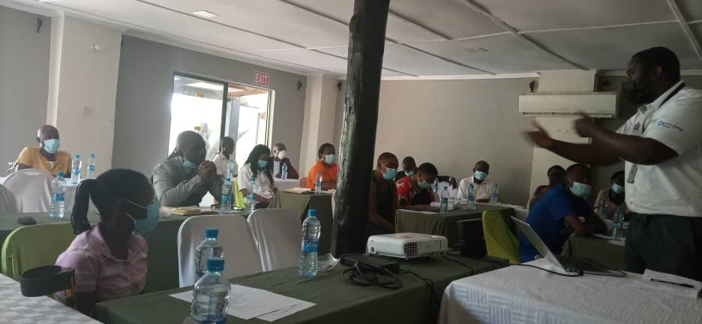

**Picture above:** Stakeholders engagement meeting held with various OPD’s in Kabwe, Central Province on Disability Inclusion in Zambia. Chota (in a white shirt) from BCH standing, is explaining how Beit Cure is helping bridge the disability inclusion gap.

**Picture Below (left):** Chirundu Audiology follow up outreach held in Chipepo and Lisutu areas. Hearing tests being conducted by 2 Hearing instrument specialists from BCH at a local health facility.

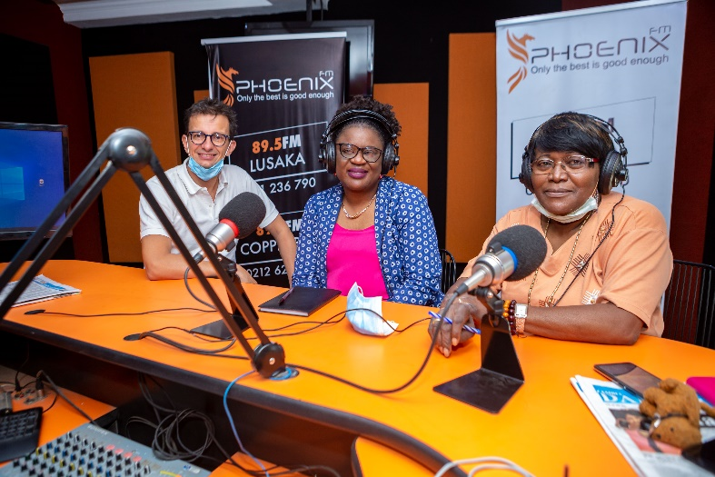**Picture Below (right):** Dr Pelham (Radio Host) (far right), Frida Kabaso Phiri (Beit Cure Executive Director) and Dr Giorgio Lastroni (Medical Director) talking about the services offered by Beit Cure Hospital including the Ear and Hearing Care Services being provided.

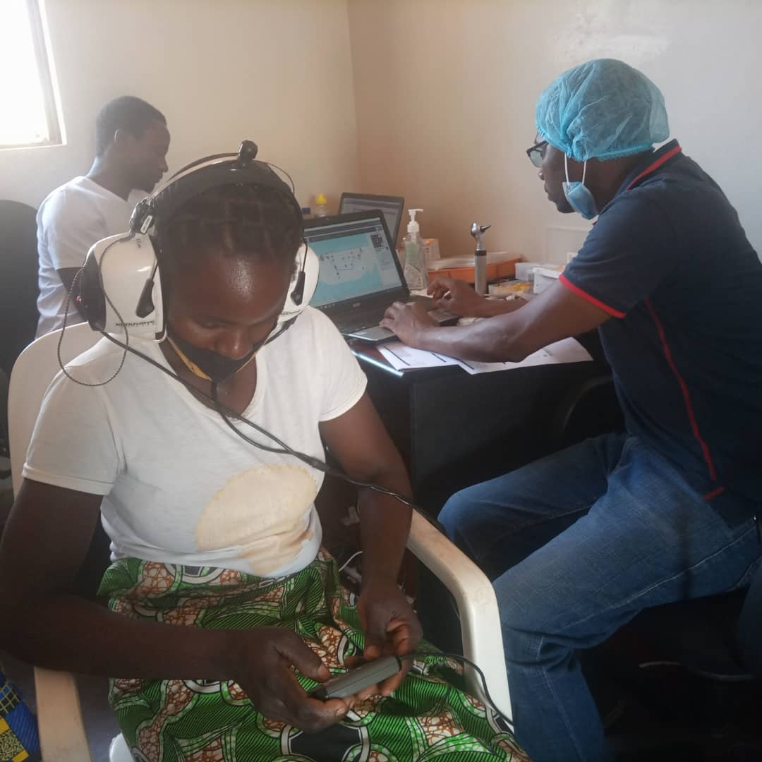

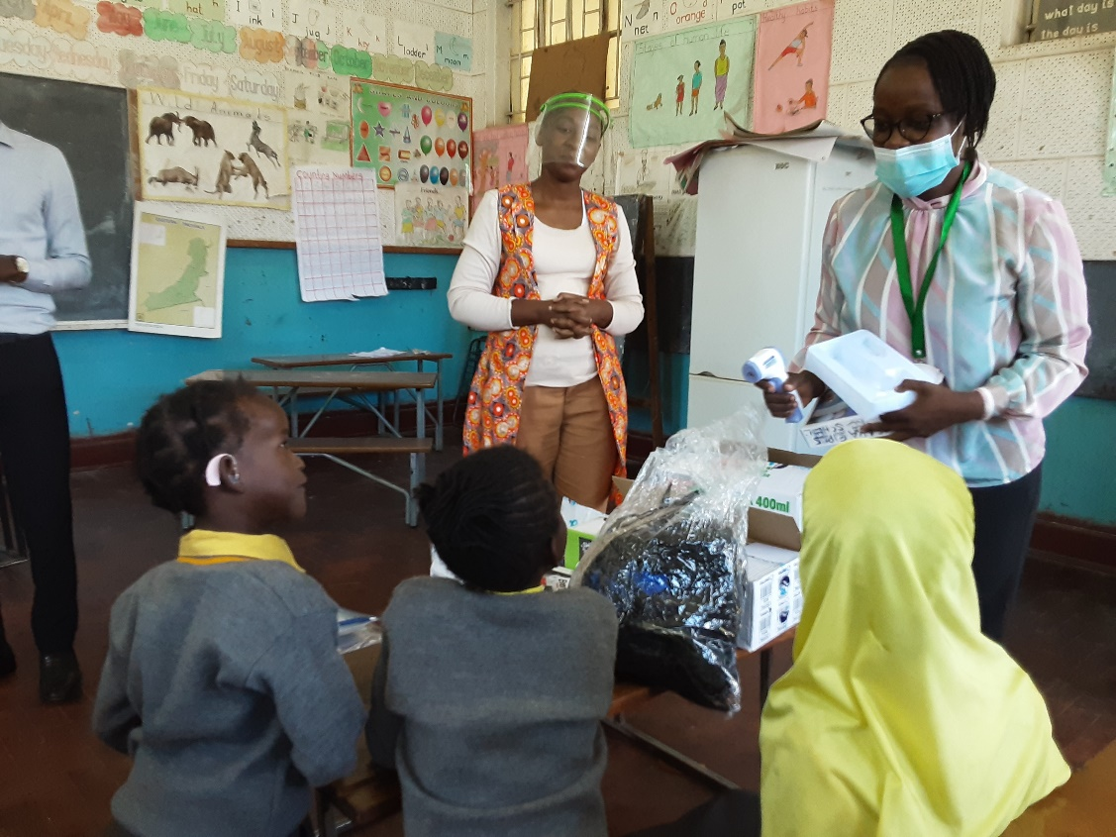

**Picture Above:** Lusaka Girls Secondary School Special Unit section. Mirriam Namundi (Community Mobilization Officer for Beit Cure Hospital) giving COVID PPE’s and demonstrating the use of the infrared thermometer to a child with a hearing impairment.

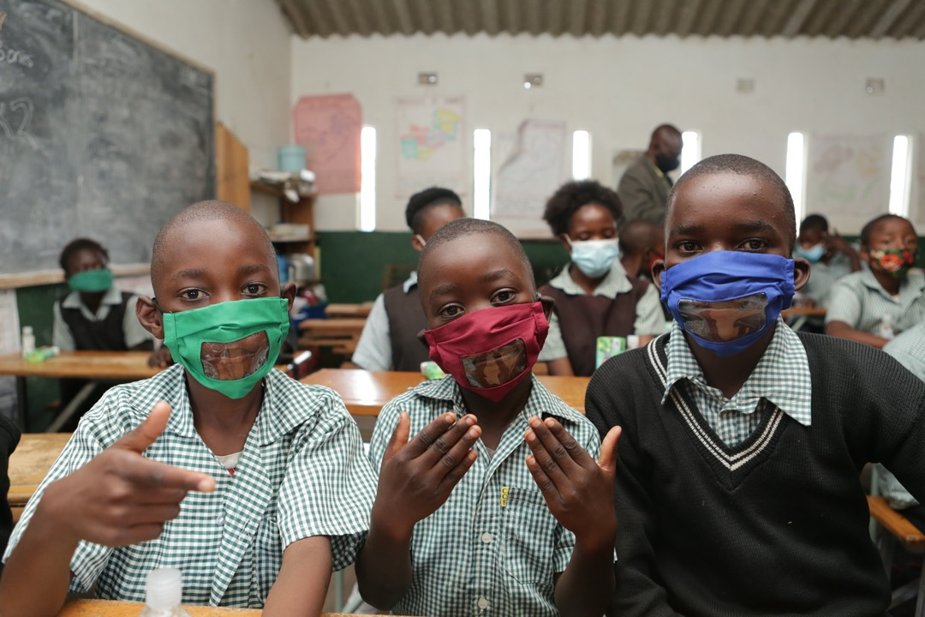

**Picture Above**: Three hearing impaired boys in grade 4 from St Lawrence Special Unit School show off their newly received COVID masks during a COVID response activity at the school.

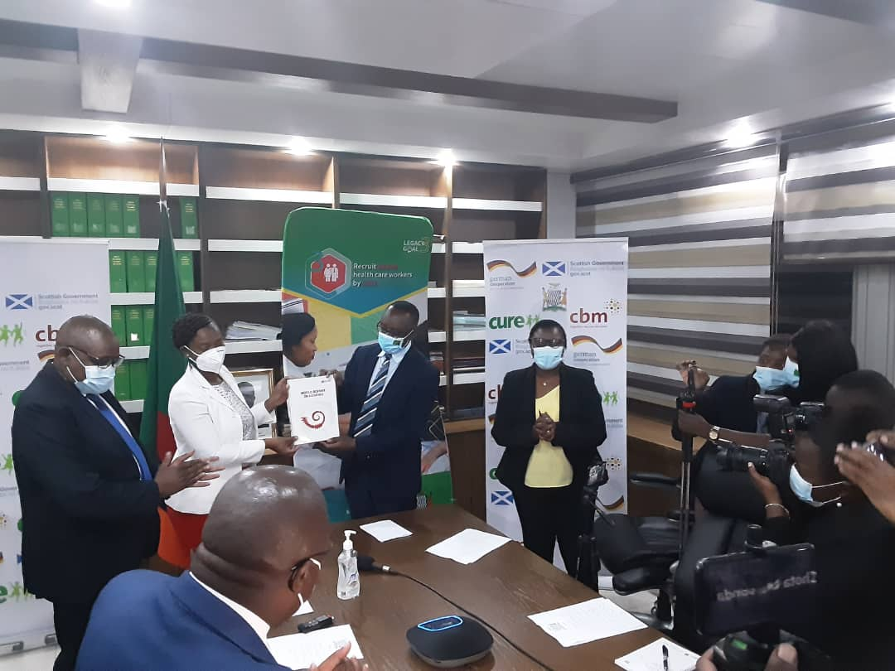

**Picture:** Virtual Launch of the World Report of Hearing by Dr Rachael Hapunda, Former Minister of Health Dr Jonas Chanda and Beit Cure Hospital Executive Director Frida Kabaso Phiri at the Ministry of Health Headquarters in Lusaka.

**Approved Construction Works:**

**PRE-FABRICATED AUDIOMETRIC BOOK**

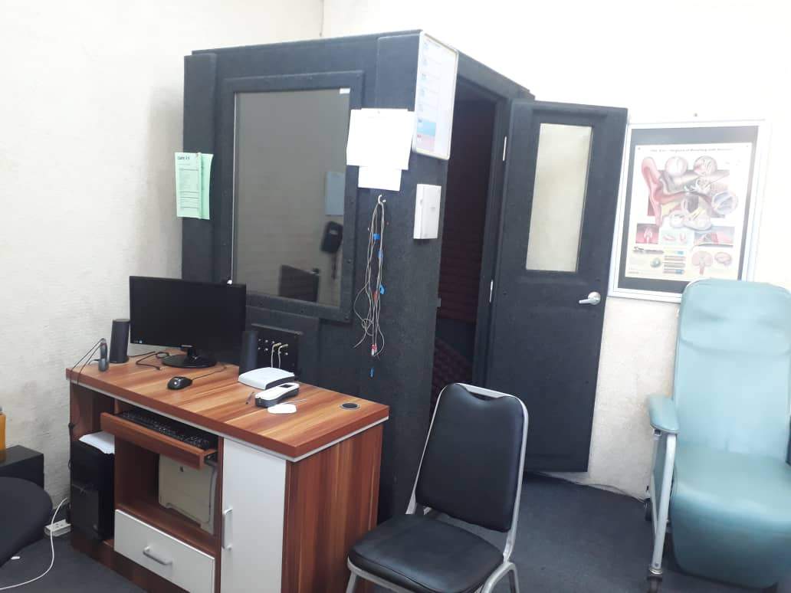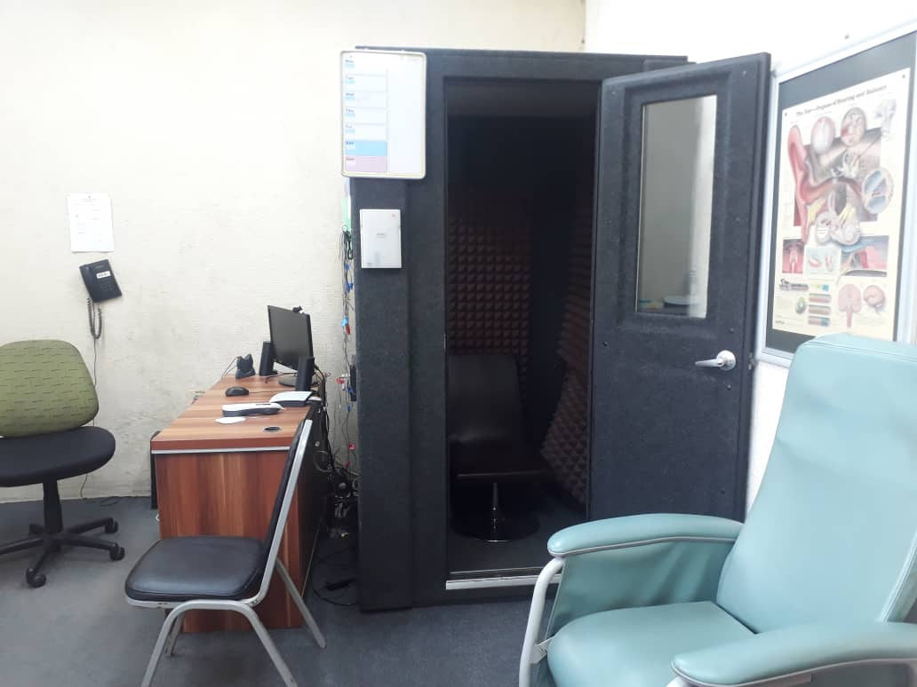

**AFTER CUSTOMIZED WORKS**

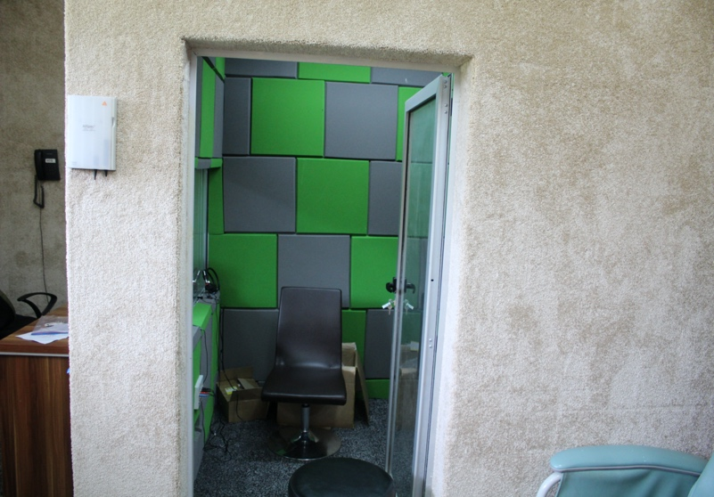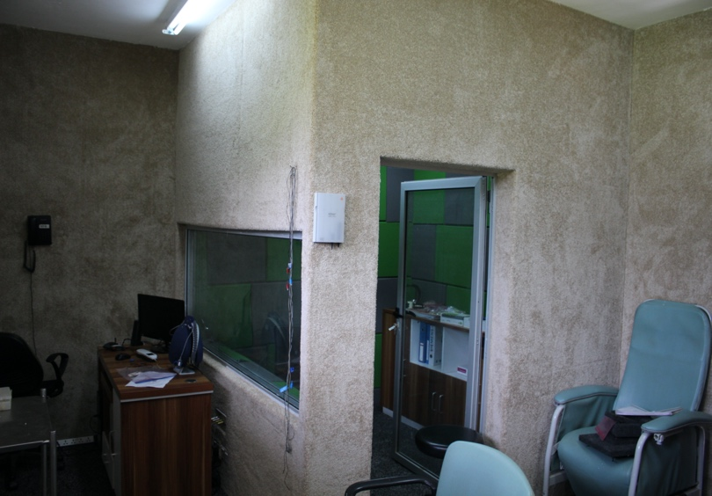

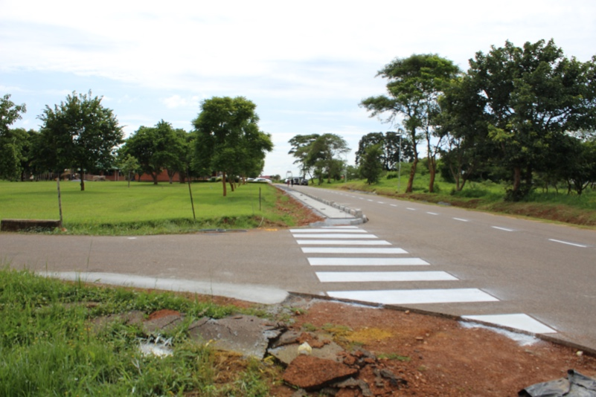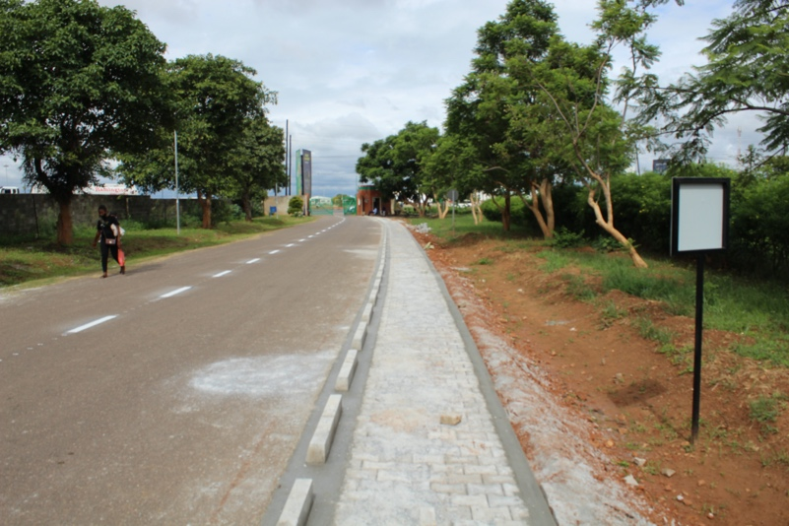**WALKWAY FROM THE GATE**

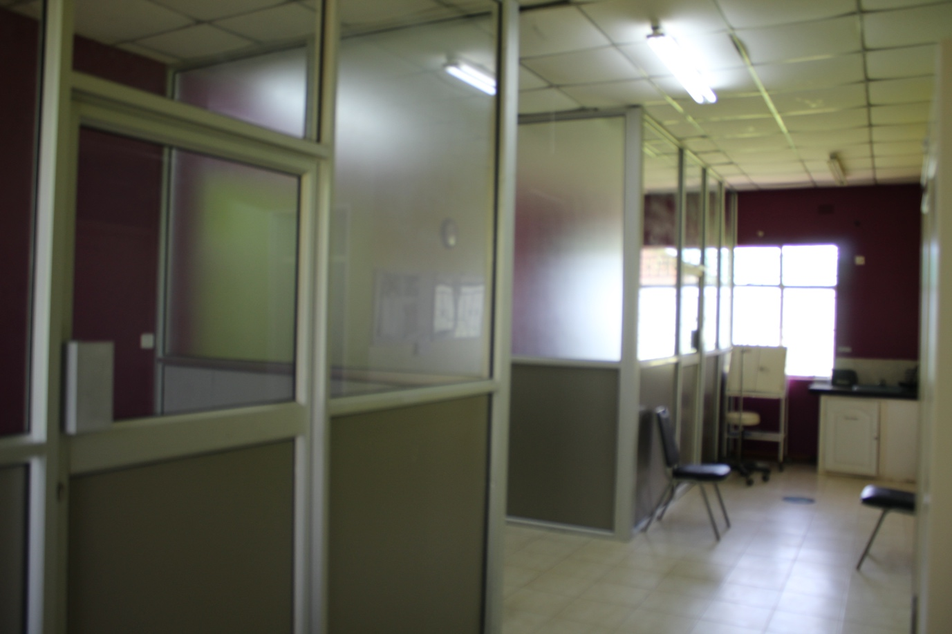**PARTITIONED ENT OUTPATIENT UNIT**

* + 1. **Stories of Change**

**Disability Friendly COVID Response!**

In an effort to curb the COVID 19 Pandemic, several guidelines were put in place to respond to the rise in the number of cases, among them the wearing of Face Masks. Despite its benefits, the generic Face mask presented a unique set of challenges for the Hearing Impaired especially with regards to Lip reading.

In response to this the project facilitated the provision of transparent Face Masks for Children hard of hearing, to ensure that communication was not affected.

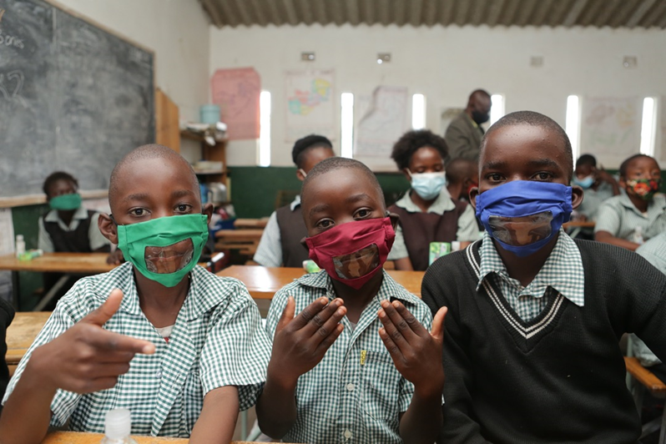

* + 1. **Updated Partner Assessment Action Plan**

An updated Partner Assessment is scheduled to be conducted in Q1, 2022.

* + 1. **Updated Project Risk Register**



**(5) Any other supporting documents as needed or agreed with CBM**



1. **COMMENTS FROM CBM**

During the period under review, project implementation and reporting was on track and satisfactory. Following a visit by the CBID Director and Regional Director to the project, it was agreed that the project submit a proposal for Infrastructural development to respond to the needs of the Patients and improve the quality of service delivery overall. This warranted an IYA which was processed in the Q4 of 2021. Additionally, the project was scheduled to come to an end December of 2021, however due to the value of the services offered by the project, the project was approved for an extension and the process of the new MYP is in progress. All the feedback received from the partner has been noted and will be actioned accordingly.

-End of document. Back to top-